The effect of dissolved salt on the boiling point of water
Aims
- To measure if dissolving salt in water changes how quickly the salt/water mixture heats up (more scientifically… the rate at which the temperature increases).
- To measure if dissolving salt in water affects its boiling point (the effect of salt concentration on Boiling Point)

Hypothesis
- __________________________________________________________________________________________________________________________________________________________________
- __________________________________________________________________________________________________________________________________________________________________
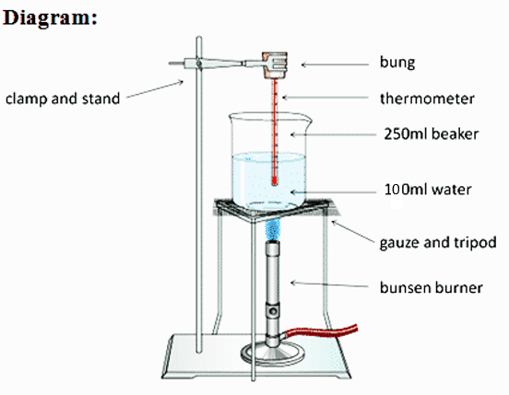
Apparatus

Stopwatch
Bunsen burner
Tripod
Gauze mat
Heat mat (for bench)
250mL Beaker
100mL Measuring cylinder
Electronic balance
Stand and clamp
Distilled water bottle
Spatula
Salt
Rubber bung
Stirring rod

Method
- Place the beaker on the electronic balance and “zero” it. Use the spatula to place 5 grams of salt into the beaker.
- Use the measuring cylinder to add 100mL of water to the beaker. Stir until the salt has dissolved.
- Carefully arrange the equipment like the diagram on the right – except the Bunsen should be unlit. See diagram above and on the right.
- Check that the bulb of the thermometer is completely surrounded by water and not touching the bottom of the beaker. Take the Bunsen burner out from under the tripod.
- Record the temperature of the water in the table below.
- Light the Bunsen and set it to a blue flame. Place it under the tripod and start your timer.
- Record the temperature every 1 minute. Keep recording until the temperature remains the same (about the same – approximately 1⁰C difference). The salt/water mixture should be boiling. Stop the Bunsen burner.
- Repeat steps 1 – 7 except with 10 g of salt instead of 5 g (in step 1).

Risk Assessment:
Source of risk | What amount of harm could it cause? (circle) | Safety precautions taken | If an incident occurred what should I do?
 | Minor / Significant / major
 | Minor / Significant / major
Results:
Table 1: The effect of concentration of salt on the heating and the boiling of water.
Mass of salt in water  (g) | Time  (minutes) | Temperature of salt/water  (⁰C) |  | Mass of salt in water  (g) | Time  (minutes) | Temperature of salt/water  (⁰C)
 | 0 |  |  |  | 0
 | 1 |  |  |  | 1
 | 2 |  |  |  | 2
 | 3 |  |  |  | 3
 | 4 |  |  |  | 4
 | 5 |  |  |  | 5
 | 6 |  |  |  | 6
 | 7 |  |  |  | 7
 | 8 |  |  |  | 8
 | 9 |  |  |  | 9
 | 10 |  |  |  | 10
Maximum temp reached = ⁰C |  |  |  | Maximum temp reached = ⁰C
Mass of salt in water  (g) | Time  (minutes) | Temperature of salt/water  (⁰C) |  | Mass of salt in water  (g) | Time  (minutes) | Temperature of salt/water  (⁰C)
 | 0 |  |  |  | 0
 | 1 |  |  |  | 1
 | 2 |  |  |  | 2
 | 3 |  |  |  | 3
 | 4 |  |  |  | 4
 | 5 |  |  |  | 5
 | 6 |  |  |  | 6
 | 7 |  |  |  | 7
 | 8 |  |  |  | 8
 | 9 |  |  |  | 9
 | 10 |  |  |  | 10
Maximum temp reached = ⁰C |  |  |  | Maximum temp reached = ⁰C

Graph 1: Temperature versus time for salt/water mix

Time (minutes)
Temperature (⁰C)
Key:

= ___ salt concentration

= ___ salt concentration

= ___ salt concentration

= ___ salt concentration

Graph 2: Boiling Point versus concentration of salt (g/L

Concentration of Salt (g/L)
Boiling Point (⁰C)
Analysis:
(First paragraph is about the first aim – reread it first – then try to complete the missing parts of the paragraph below)
The ________________________________ dissolved in the water did / didn’t affect the boiling point of the water. As the _______________________________ increased the boiling point of the water increased / decreased / remained the same. When ______ g of salt was dissolved in the water the boiling point was _____ ⁰C. When the ______ g of salt was dissolved in the water the boiling point was _____ ⁰C. The boiling point of the salt solution increased by _______ ^{O}C for every one gram/litre increases in salt concentration.
(Second paragraph is about the second aim – reread it first – then try to complete the missing parts of the paragraph below)
The ________________________________ dissolved in the water did / didn’t affect the rate at which the water heated up. As the _______________________________ increased the water heated up faster / slower / the same rate. When ______ g of salt was dissolved in the water, the water heated up at a rate of _____ ⁰C per minute. When ______ g of salt was dissolved in the water, the water heated up at a rate of _____ ⁰C per minute. This data shows how the rate at which the water heated ________________________ _______________ when the mass of salt dissolved in the water was increased.
(Third paragraph is about errors – the first sentence is easy, but then you have to list the errors and how you would fix them if you were to do the experiment again.)
There were no / few / significant / many errors in this experiment. The most important error(s) was/were ______________________________________________________________________________________. Another error was _______________________________________________________________________ ______________________________________________. These errors could be corrected if we _________ ____________________________________________________________________________________________________________________________________________________________________________
Conclusion:

Write the first sentence of the first paragraph of your analysis.  Explain by describing the relationship between the boiling point and salt concentration in more detail. Is it linear (straight line), is it curved? Up or down curve?  Explain the implications of the relationship.  Write the first sentence of the second paragraph of your analysis. Explain by describing the consistency of the pattern across all the lines (graph 2). Are all the lines a similar shape (consistent)?  Explain the implications of the relationship | __________________________________________________________________________________________________________________________________________________________________________________________________________________________________________________________________________________________________________________________________________________________________________________________________________________  __________________________________________________________________________________________________________________________________________________________________________________________________________________________________________________________________________________________________________________________________________________________________________________________________________________

What is the mathematical form of the relationship between boiling point and Salt concentration?
To figure out the equation to the straight line in graph one, we need to do two things:
- Calculate the slope of the line using $slope= \frac{y_{2}- y_{1}}{x_{2}- x_{1}}$ (b) Find where the line crosses the vertical axis

